Image classification using Python and Keras

Name of student

Name of professor

University

Course

Date

**Introduction**

Machine learning and modeling have become a common interest in the field of industrial sciences. For instance, in the field of industrial chemistry, health care, finance, marketing, computer navigation and vision and some elements of artificial intelligence greatly rely on machine learning. The machine learning processes, follow three main stages and the architecture for this is indicated as per the below:

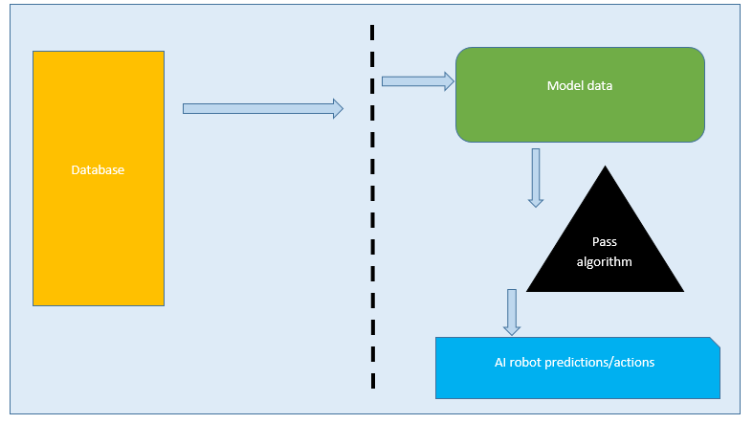

The application takes the data stored in the database, passes models into the dataset, then using the respective algorithm assigned to the dataset, a prediction and classification is made. The process involves continually supplying sets pf data into the application for train and test until the required output is met for accuracy. Also known as the parent rule, 80% of the supplied data will be used for training while 20% of the data shall be used for testing purposes.

It is required that the supplied data should be able to meet at least 80% accuracy on classification models. This way, it becomes much easier to predict with the model. The models take the characteristics specific to the image and store them, then look out for them against a database, if the characteristics match, then the machine knows how to classify them. For instance certain features like height, color patterns, size, shape, text positions and size, will help the model know which class an image belongs to. The larger the dataset, the better for accuracy.

**Problem statement:**

In this activity, we are going to try to classify an image as either based on which particular sport or game. Consider a game like soccer, football and rugby, these games have so much in come such that when a random photo is supplied, one may not be able to immediately tell if belongs to the whichever sport that has been identified.

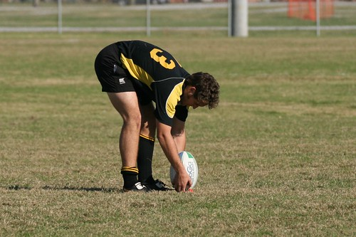

Considering the image above, we may not be able to immediately tell if the sports in questions is soccer, rugby or American football. To the common user, this is easier to achieve and classify whereas to the machine, a lot has to be done to improve this image so that the correct classification can be supplied on the dataset. This would involve some factors like the size, shape color, open text and object position patterns on the image. So in order to achieve this, Python language has very powerful models and algorithms written to it by other software engineers elsewhere that solve problems like this.

**Dataset description**

This activity involves data captured both from the Google’s Open Image library and the Image Net website. Further, the data consists of 3058 instances / occurrences. Part of this data are images that belong to soccer and the other part are images that belong to Soccer and the other bit is for Rugby. The dataset is further split into training and test, bearing in mind the concept of the Pareto rule. So the breakdown of the dataset would look like below:

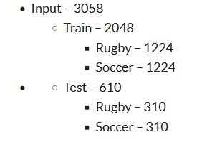

The analysis shall be done using Jupyter online IDE and Python Keras is another library package that shall be used to score the classification of these images. The next step is the analysis bit.

Importing the libraries needed for the task:

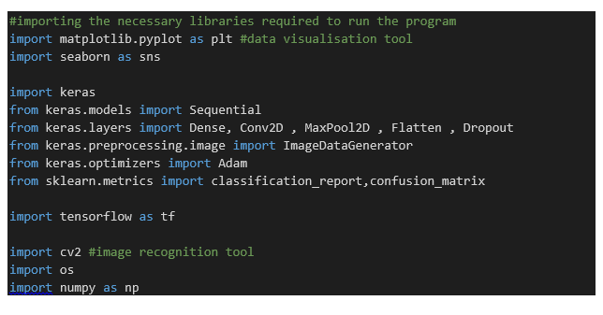

Then we define the location where we want to get the dataset and then using pythons function, we call it to grab the data that we need. OpenCv then lets us read the image values.

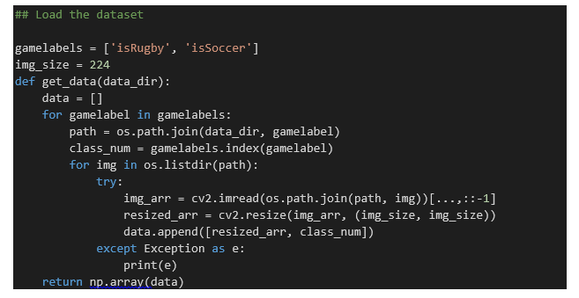

Then the next phase is to visualize the data we are working with to try and grab the output in the form of a graph;

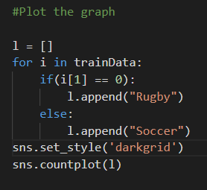

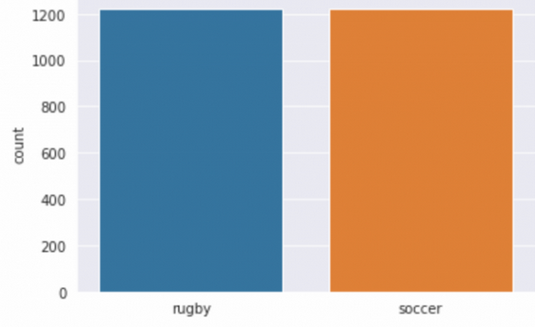

After this, we can now try to randomly grab a single image from the files and visualize it using the below code;

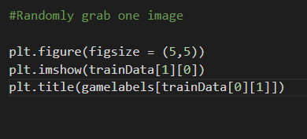

Once we run this code, we get the below sample image output;

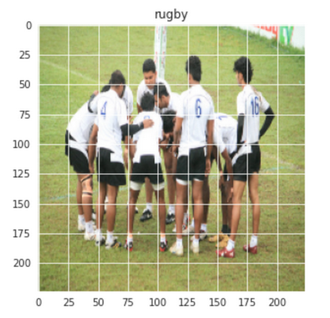

We can also do this for Soccer and try to see the resulting output;

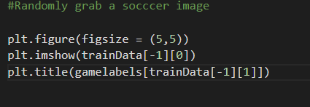

This will result in the below image;

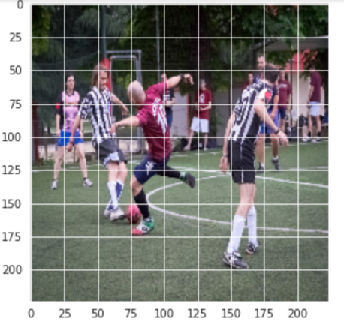

Before we conduct the final data prediction with Keras, we do data augmentation and preprocessing just to align the model;

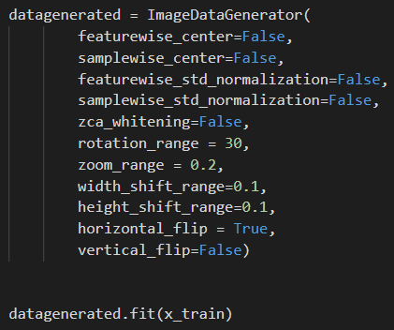

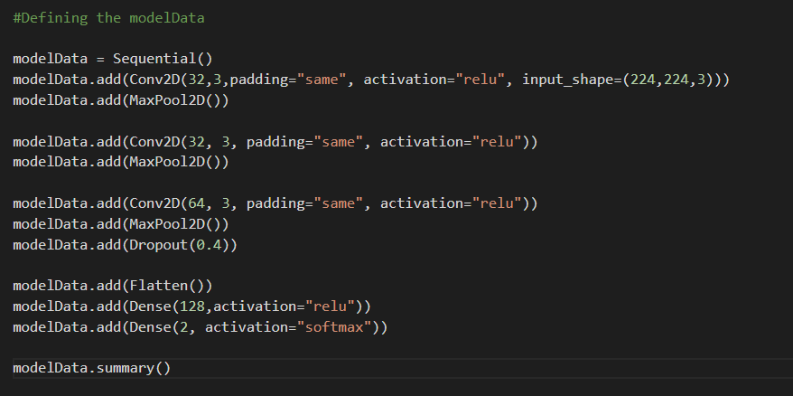

Results evaluation with the data;

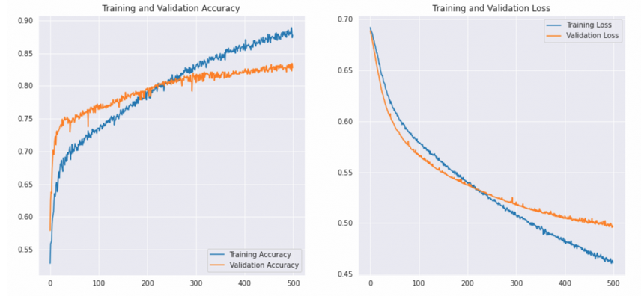

We can therefore move ahead to print the classifications to detect the accuracy resulting from the model

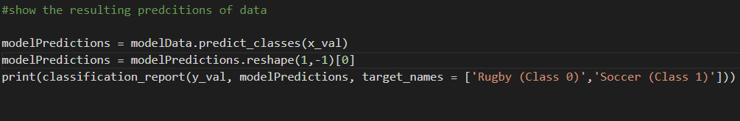

Predicting the resulting model

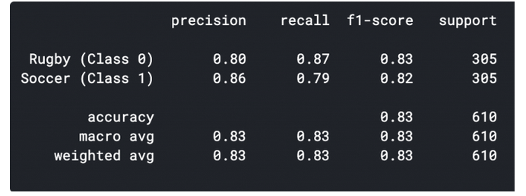

The model as seen is able to predict the images with an accuracy percentage of 83%, this is highly reliable as per the model